**Boxify : Sales Analysis and Inventory Insights – Project - By Saloni Prasad**

**GIT HUB LINK - https://github.com/Saloniprasad17/Boxify-Sales-Analysis-and-Inventory-Insights-Project.git**

**Instruction**

Effective inventory management is essential for businesses to maintain optimal stock levels, minimize carrying costs, and meet customer demand. As a data analyst, your task is to analyze a sales dataset, extract valuable insights, and provide inventory-driven recommendations to enhance inventory management practices.

**Objectives:**

1. Analyze the provided sales dataset to understand sales trends, stock levels, and product performance.
2. Identify popular products, low-stock items, and sales patterns over time.
3. Generate actionable recommendations for improving inventory management efficiency.

**Tasks/Activities List:**

1. Data Collection and Preprocessing:
   * Obtain the sales dataset from the provided source: [Sales Analysis Dataset](https://kh3-ls-storage.s3.us-east-1.amazonaws.com/Data%20Analyst%20Project/Boxify%20Dataset%20-%20Data%20Analyst%20Bootcamp.csv).
   * Clean and preprocess the data to handle missing values and inconsistencies.

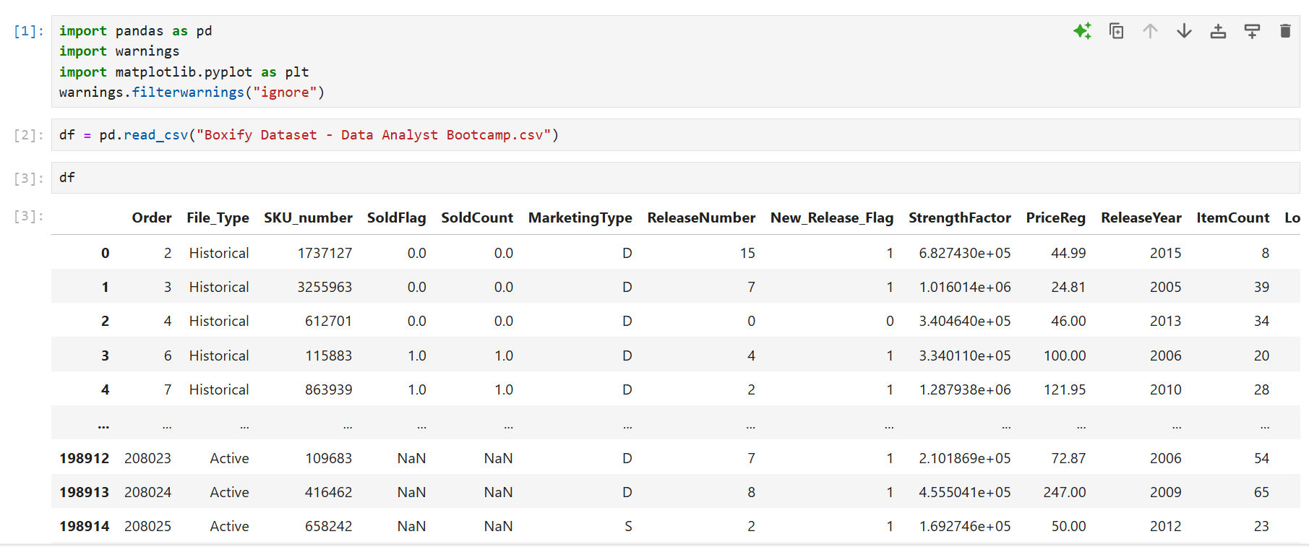

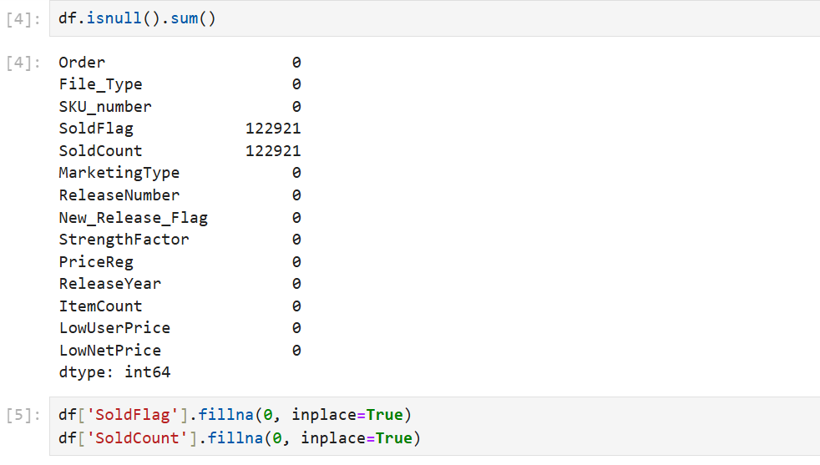

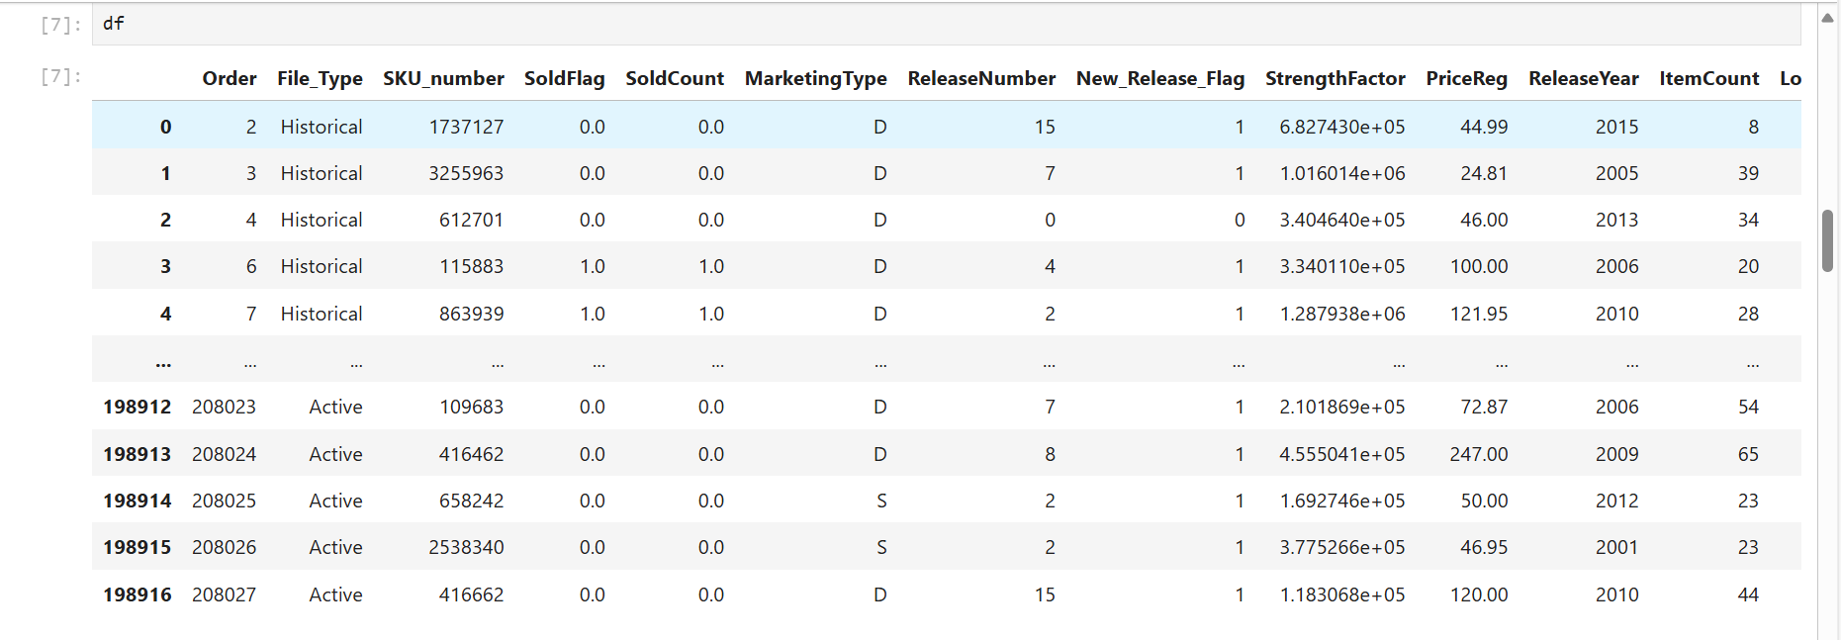

Exploratory Data Analysis (EDA):

Analyze sales trends and variations over time

**2. Exploratory Data Analysis (EDA):**

* **Analyze sales trends and variations over time**
* **Identify top-selling products and categories.**
* **Investigate stock levels and low-stock items.**

**Analysing Sales trends**

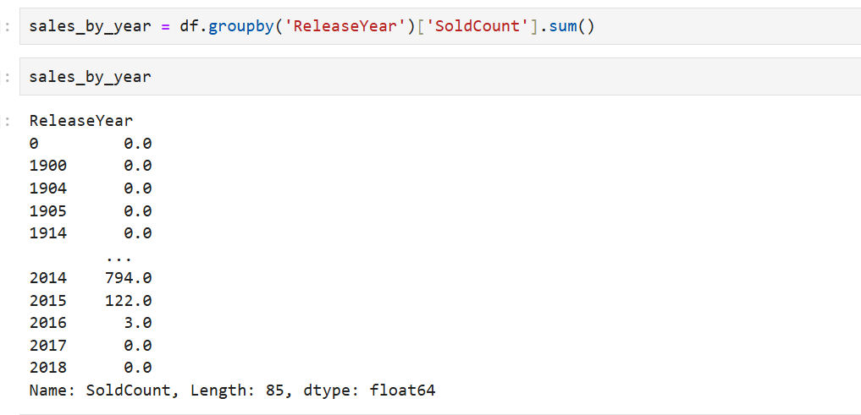

**TOP 10 products**

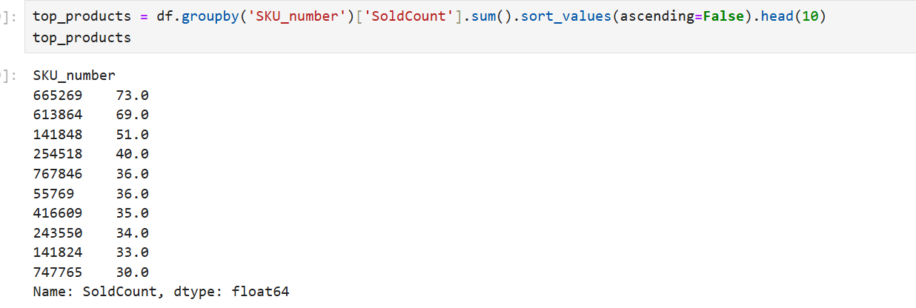

**Top Categories**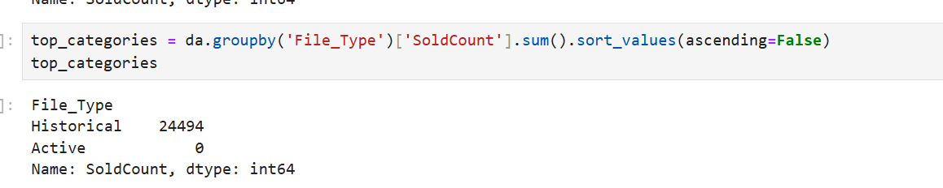

**Investigate stock levels and low-stock items.**

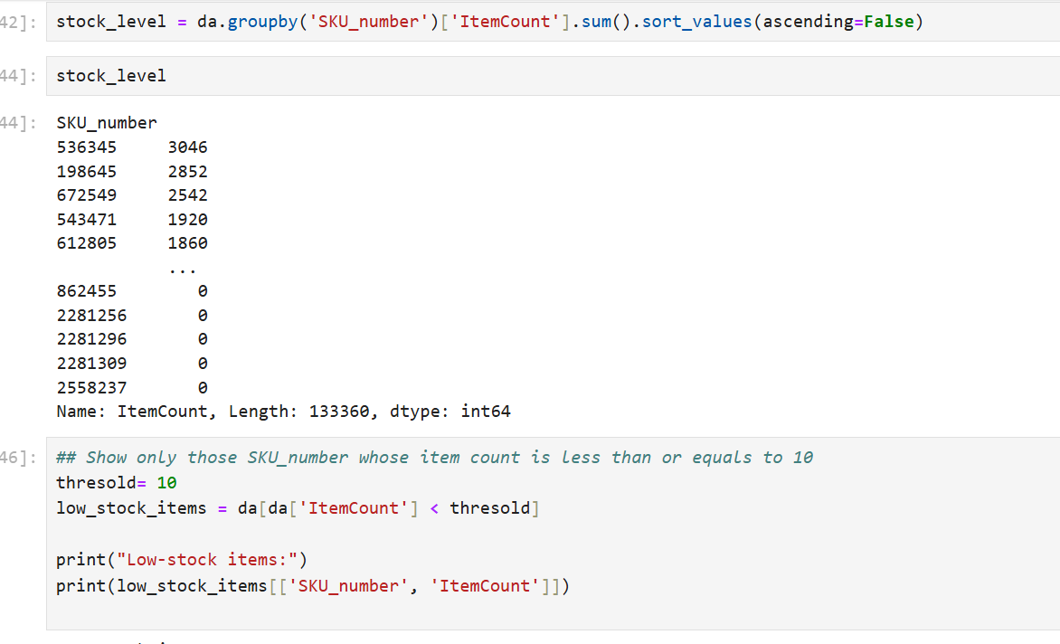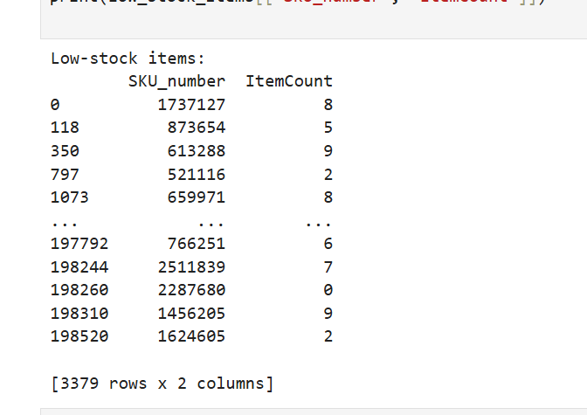

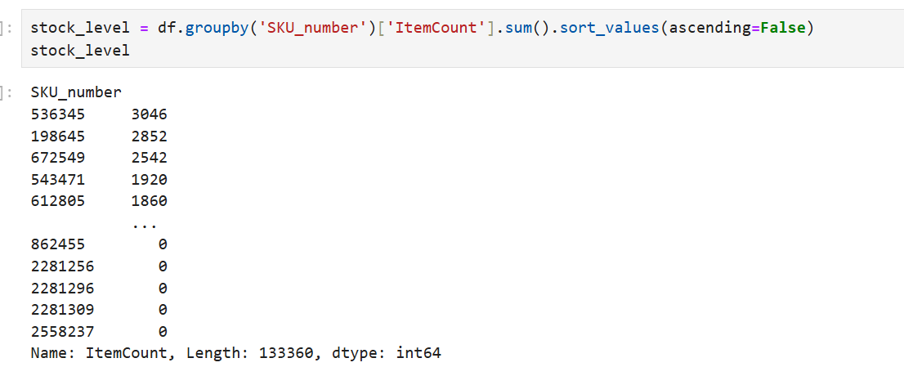

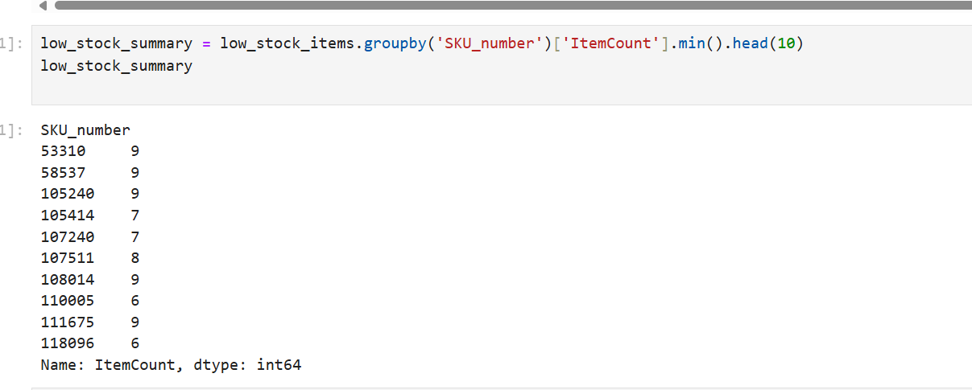

3.Inventory Insights and Recommendations:

1. Calculate key performance indicators (e.g., inventory turnover, stock-to-sales ratio, reorder points).

Average Inventory: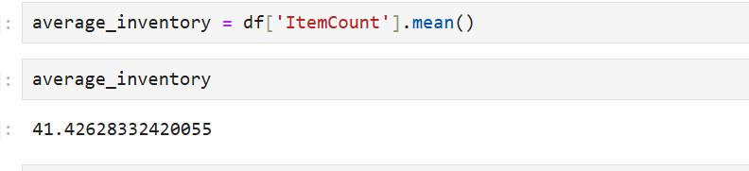

**Stock To Sales Ratio:** 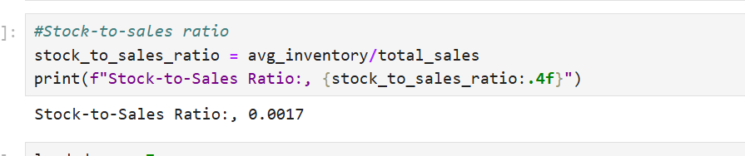

Inventory Turnover Ratio: 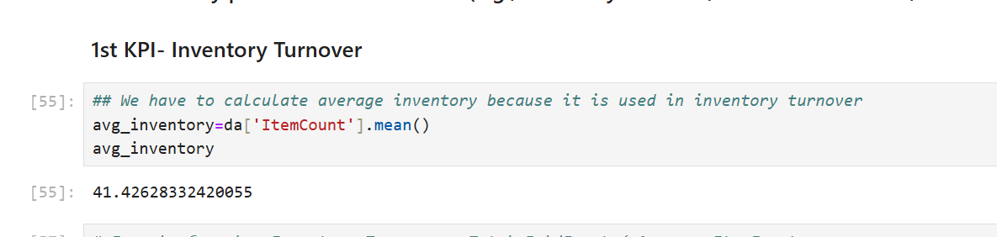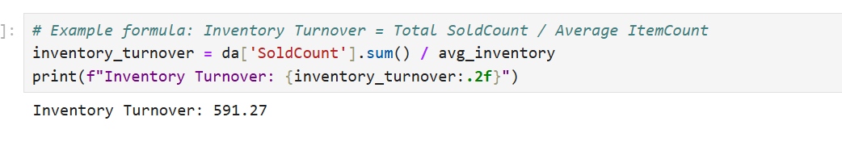

Total Sales: 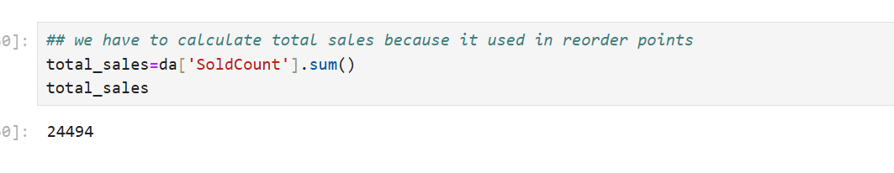

Reorder point: 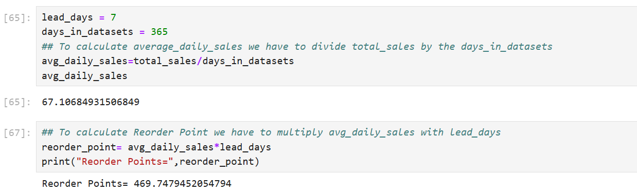

1. Provide actionable recommendations to optimize inventory management based on sales patterns.
2. **Adjust Safety Stock Levels**

* **Insight**: Identify products with fluctuating or high demand using historical sales trends.
* **Action:** Maintain higher safety stock levels for these items to prevent stockouts during demand spikes.
* **Benefit**: Improved customer satisfaction and reduced lost sales opportunities.

**2. Automate Low-Stock Alerts**

* **Insight:** Track low-stock items frequently and automate alerts when inventory reaches reorder points.
* **Action:** Set up an automated inventory management system to trigger restocking notifications.
* **Benefit:** Proactive replenishment prevents interruptions in the supply chain.

**3.Focus on Top-Performing Products**

* **Insight:** Top-selling products contribute significantly to revenue.
* **Action:** Allocate more inventory to these products and prioritize their availability.
* **Benefit:** Higher sales and improved profitability.

**4. Optimize Inventory Turnover**

* **Insight:** Calculate and monitor inventory turnover rates to assess efficiency.
* **Action:** Rotate inventory regularly, focusing on products with slower turnover rates.
* **Benefit:** Reduced holding costs and minimized risk of obsolescence.

1. Data Visualization:
   1. Create interactive and informative visualizations (e.g., line charts, bar plots) to present sales trends and inventory metrics.
   2. Highlight insights through well-designed graphs and charts.

**1.Sales Trends over time**

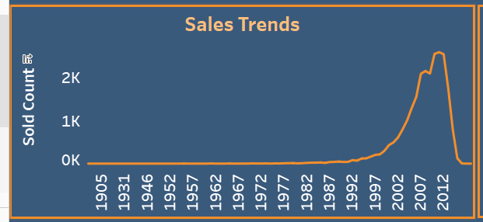

1. **Top 10 products** 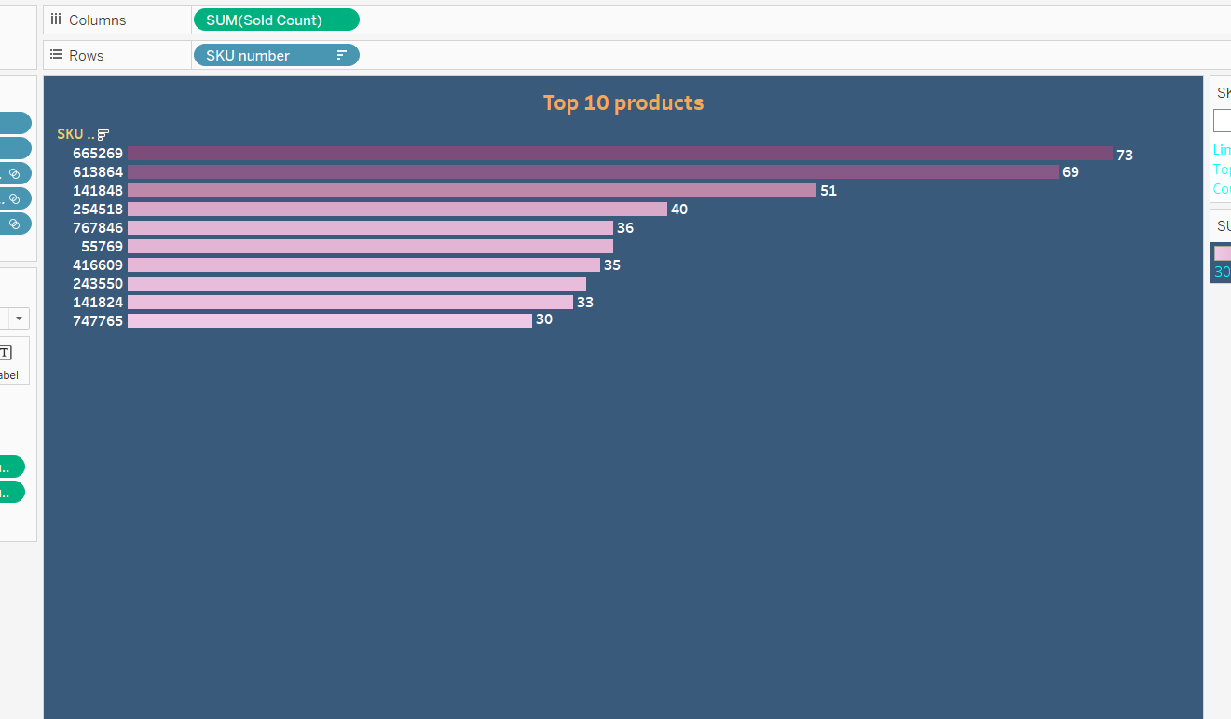

**3.Top Category:**

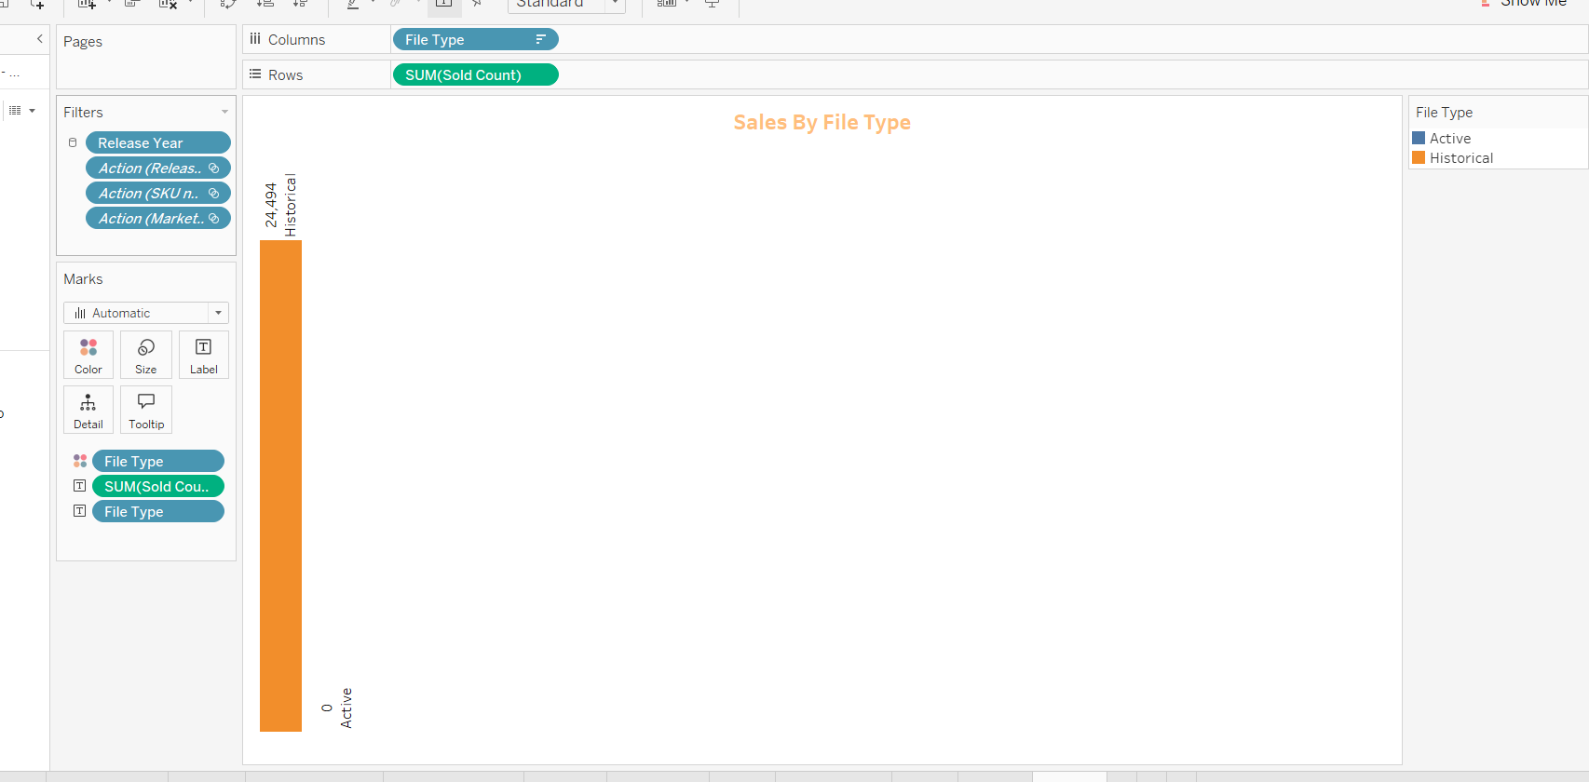

* 1. **Low stock items**

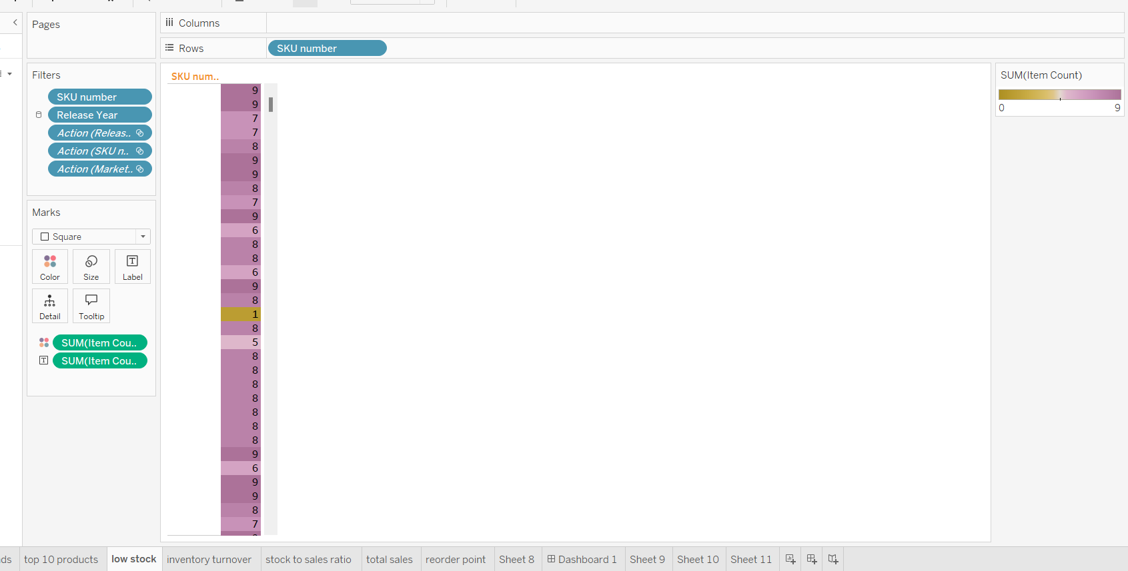

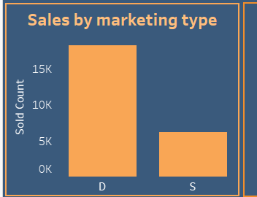

**Inventory Metrics:**

**key performance indicators (e.g., inventory turnover, stock-to-sales ratio, reorder points and total sales).**

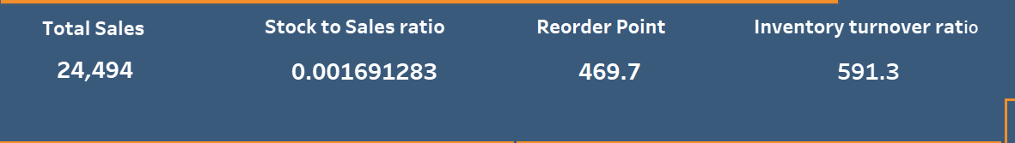

**5 .Documentation and Reporting:**

**Summarize the findings, inventory-driven insights, and recommendations from the analysis.**

**Explain how the inventory-focused insights can benefit businesses in enhancing inventory management.**

**Summary of Findings:**

1. **Sales Patterns and Trends:**
   * Seasonal Peaks: Sales data reveals significant spikes during specific months, indicating seasonal demand for certain products.
   * Consistent Top Performers: Certain products consistently rank as best-sellers, driving a large portion of revenue.
2. **Inventory Performance:**
   * Low-Stock Items: Identified products that frequently run out of stock, leading to potential lost sales.
   * Overstock Issues: Highlighted items with slow turnover rates, occupying storage space and increasing carrying costs.
3. **Key Performance Indicators (KPIs):**
   * **Inventory Turnover Ratio**: Indicates the speed at which inventory is sold and replaced. Some categories exhibit inefficient turnover rates.

**Stock-to-Sales Ratio**: Identifies mismatches between stock levels and actual demand.

**Reorder Point**: The reorder point 469.7 tells us that When the inventory level of that product drops to approximately 470 units, it is time to place a new order.

* **Explain how the inventory-focused insights can benefit businesses in enhancing inventory management.**

**1 Optimized Stock Levels:**

**Explanation:** By analyzing sales patterns and demand forecasts, businesses can maintain optimal stock levels. This ensures that they have enough inventory to meet customer demand without holding excess stock, which ties up capital and incurs storage costs.

**2 Cost Reduction**:

**Explanation**: Efficient inventory management minimizes carrying costs, reduces wastage, and optimizes the use of warehouse space. This leads to significant cost savings, enhancing overall profitability.

**3. Accurate Reorder Points:**

Prevention of stockouts and overstocking.

**Explanation**: Insights from sales data and inventory turnover rates help in setting accurate reorder points. This ensures timely replenishment of stock, preventing both stockouts and excess inventory.

Utilize advanced visualization tools like Plotly or Tableau for interactive visualizations.

